**Rosetta Stone:**

**A technique for communicating novel information using elements of common understanding.**

Sometimes trying to understand new concepts or information can seem all but impossible. The learning mind reaches far and wide to draw from existing connections and indicators to solve the current puzzle. It can feel like peering through an impenetrable haze to make out some indistinct shape. However, with the right tools and techniques, the picture becomes clearer, and the learner can see the pattern and understand the concept. A design principle that reflects these tools is known as a Rosetta stone, which is a technique for communicating novel information using elements of common understanding. The stone that this principle is named after has enabled modern humans to understand ancient Egyptian writing, yet the concept is also employed in the common crossword puzzle and the lofty reaches of [interstellar communication](https://en.wikipedia.org/wiki/Pioneer_plaque). Designers and educators can use the principle across courses, systems, and demographics. Anytime new information is to be deciphered or understood, consider the use of keys, references, and archetypal representations to help the learner draw appropriate conclusions and make accurate classifications. When doing so, it is important to highlight the significance and use of the key itself. It must be clear what the key is and how it should be used. The Rosetta stone can come in many forms such as a stand-alone tool, as marginal information, or embedded within the content itself which the student can readily use to compare newly presented information with a known reference.

Our mind’s eye has a wonderfully resourceful and effective [pattern-seeking apparatus](https://bigthink.com/endless-innovation/humans-are-the-worlds-best-pattern-recognition-machines-but-for-how-long). It is an incredibly efficient and usually accurate, system that saves time and mental calories. Seeing patterns and connections happens so often and so quickly that we rarely notice it unless an error occurs. Rosetta stones, when designed for and employed appropriately, allow us to employ this system while keeping learning on track. They can be used in-line with other universal design principles like advance organizers, archetypes, recognition over recall, and performance load. Recognition and performance load are especially useful here because of the cost-benefit, where we get the speed and accuracy of recognition while reducing extraneous information. Additionally, Rosetta stones can help the designer and educator meet [UDL](http://udlguidelines.cast.org/) guidelines of Sustained Effort & Persistence, Language & Symbols, and Comprehension. Effective employment should increase attention, add novelty, and the feeling of discovery. With the possibility of finding new and different things, engagement should also increase. A well designed and used key reference also provides seamless and timely error correction and feedback. Better still, all this can be accomplished while saving time and real estate via the use of iconic imagery and previously learned information.

**Rosetta stone for Math**

Mathematical concepts both abstract and concrete can take time to understand and remember, both because of the sheer volume of symbols we are expected to learn, and because of the operations they represent. Implementing charts and available reference material can be useful keys to unlocking each symbol's potential. Here is an example chart of both common and more obscure symbols that can be easily referenced due to its use of chunking and color-coding.

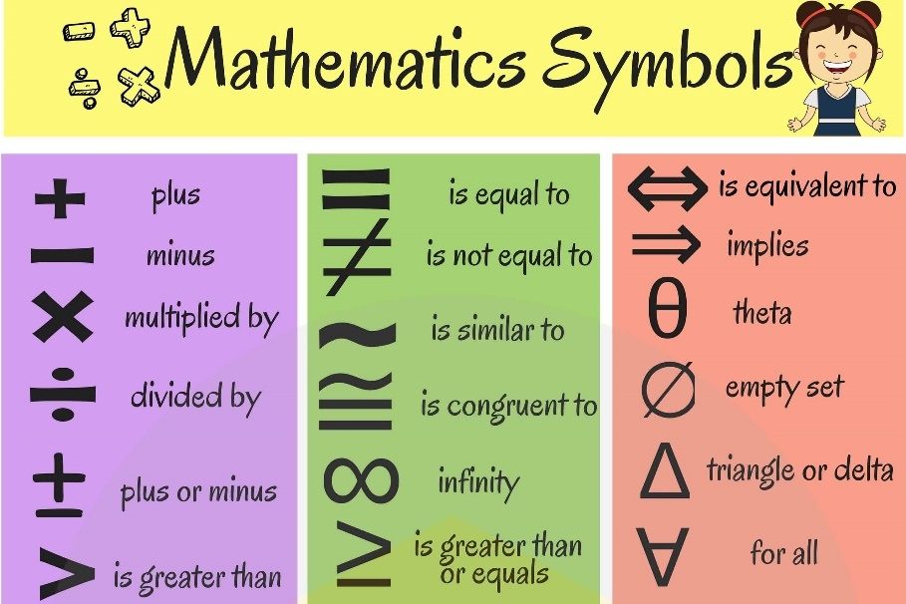

**Rosetta stones in maps**

Trying to navigate an unfamiliar place can be especially challenging if the map you have for navigation is hard to understand. Most well-designed maps circumvent this through the use of easy to recognize symbols, keys, and marginal information. This example of the London Metro does a fantastic job of embedding its Rosetta stone in the lower right-hand corner, helping riders see where to go, and find their way more easily. This type of key concept can be imbedded in learning material to better comprehend unfamiliar content.

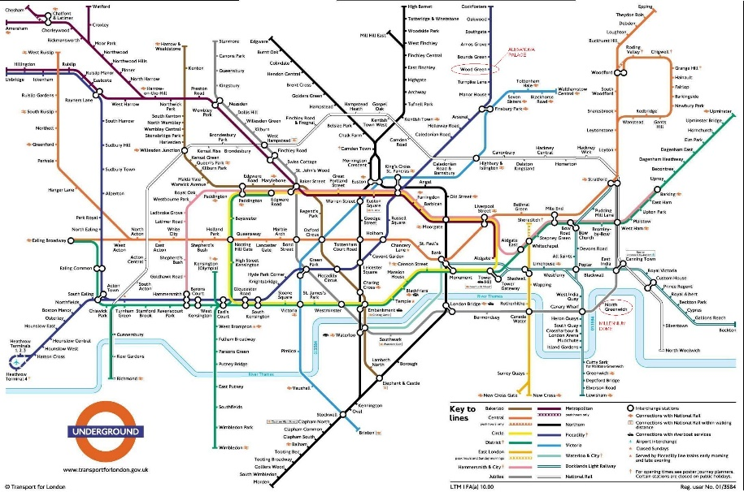

**Rosetta stones in natural science**

The natural Sciences are host to many subjects that benefit from the use of a Rosetta stone like feature. This example of a dichotomous key has a couple of beneficial characteristics. It helps the user correctly identify a given tree type and to visualize where each tree stands categorically in relation to the others. Not all the columns keys require the use of imagery but as we can see in this example using text and pictures together can make it easier to traverse. This is a specific use case, but as a model the dichotomous key can be employed throughout education and training to better identify and understand concepts.

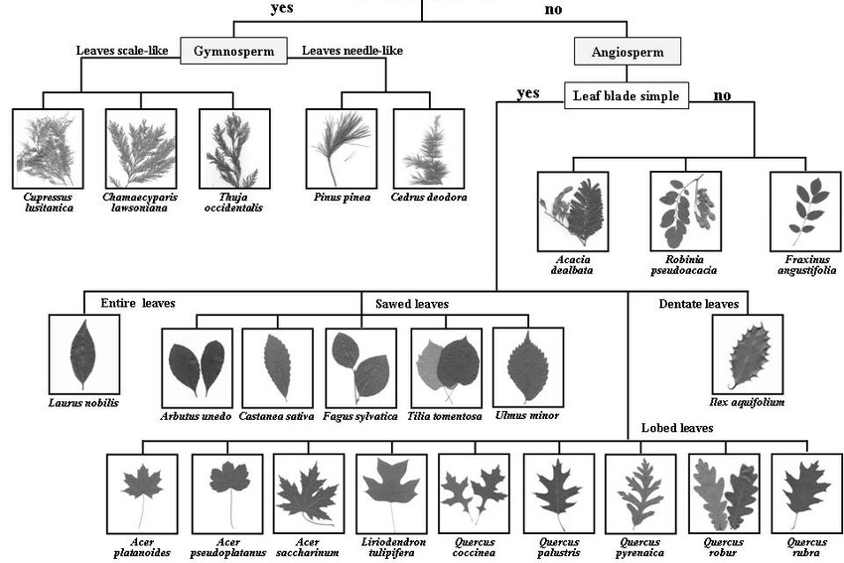

**Rosetta Stone for anatomy**

The human body is a wondrous electrochemical machine. It plays host to innumerable processes that often go unseen yet that we rely on countless times throughout the day. This example of the anatomy and movement of the hand and wrist is an effective representation of a reference poster that we could find in a doctor's office or a biology classroom to help the patient or student understand component parts, innerworkings, and nomenclature. Note the use of the ball and arrows, common symbols, to relay force and motion.

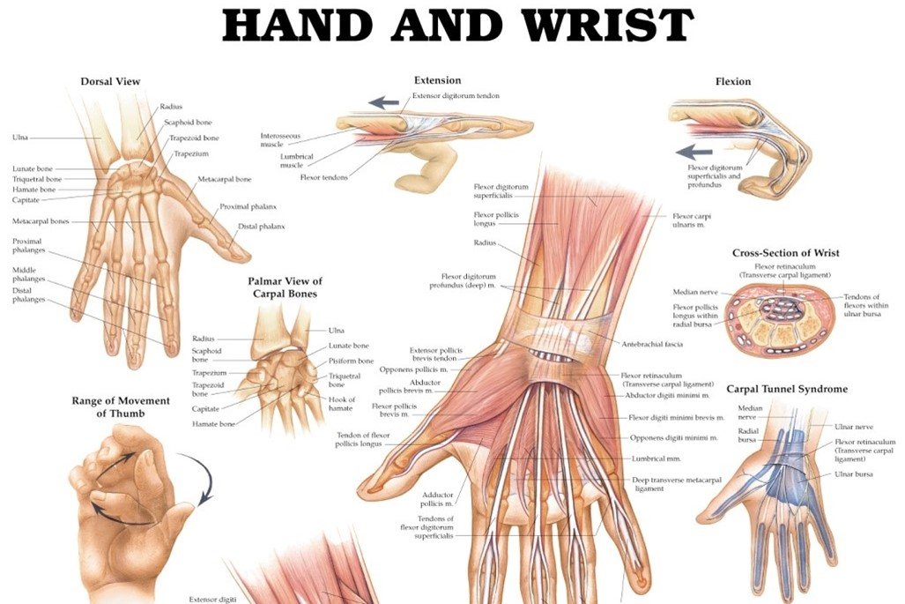

**Charts can be a Rosetta stone**

Reference charts can be useful for even the most mundane bits of information. On the left is an example of a volume conversion chart that acts as a quick reference to understand standard measurement. This example is made more effective through the use of symmetry and simplicity, along with the corresponding text. On the right we have an easy to read fire extinguisher chart that helps the user match the appropriate fire extinguisher with the type of fire that they may be faced with. Not only to understand which fire extinguisher they should purchase but also to help keep the situation from going from bad to worse.

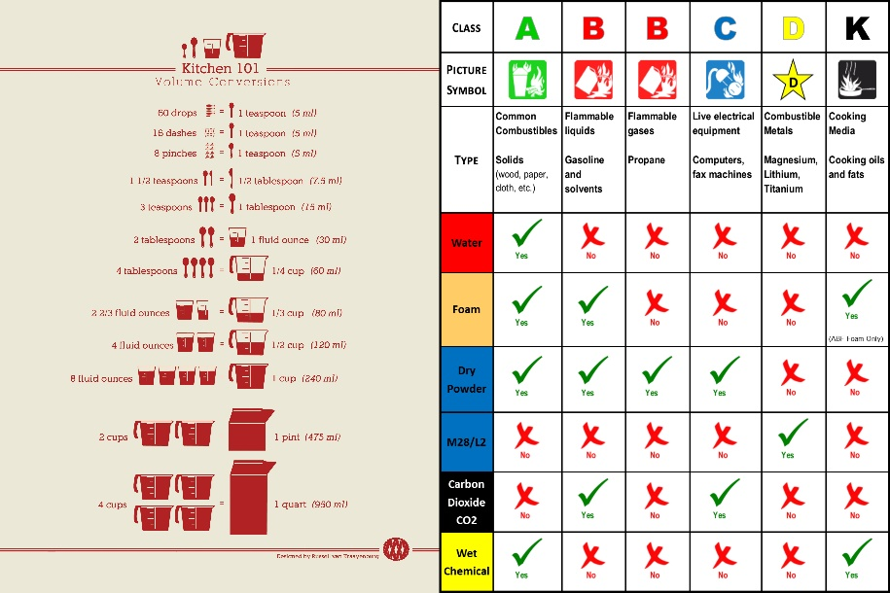

Duane Gregory - WTAMU course 6310 - Summer II - 2020